**UpLift Fit Database**

*Fernando Database Solutions*

*26th May 2024*

HEADING PAGE

* Overview 1
* Client Requirements 1
* Database Entity Relation Diagram 2
* Mock Ups 3-9
* Client Feedback

**Overview**

The clients business UpLift Fit is a gym personal trainer business where the business allocates trainers to clients.

Clients pay a onetime session fee or can pay for a membership where the trainers always help the client with their diet and workout sessions.

The Database aims to handle the data storage for the entire Member (Clients), Trainers, Employees and the Training sessions they would have. Making it easier for UpLift Fit to assign Clients and Trainers according to their Location.

**Client Database Requirements**

These are the basic database requirements for the client.

* Tracking the number of clients and trainers
* Type of Training packages
* Areas of the clientele
* Costs of Trainers
* Training Sessions
* Employee Contracts
* Employee Positions
* Clients Details
* Trainer Details

**Database Entity Relationship Diagram**

The Below Relationship Diagram show all the Relationships between the tables, Cardinality of the relationships, Attributes of the tables, Specifications of the data types.

It contains a Training Session table which helps the business to keep track of all the training sessions each trainer has been assigned to. Client Area and Trainer Area table is added to help UpLift Fit to assign a Client and Trainer who are in the same Area/City. Package Type table to help them identify which type of Package the client has chosen for example (Weight Lifting Program, Yoga Program, Cardio Program and etc.. )

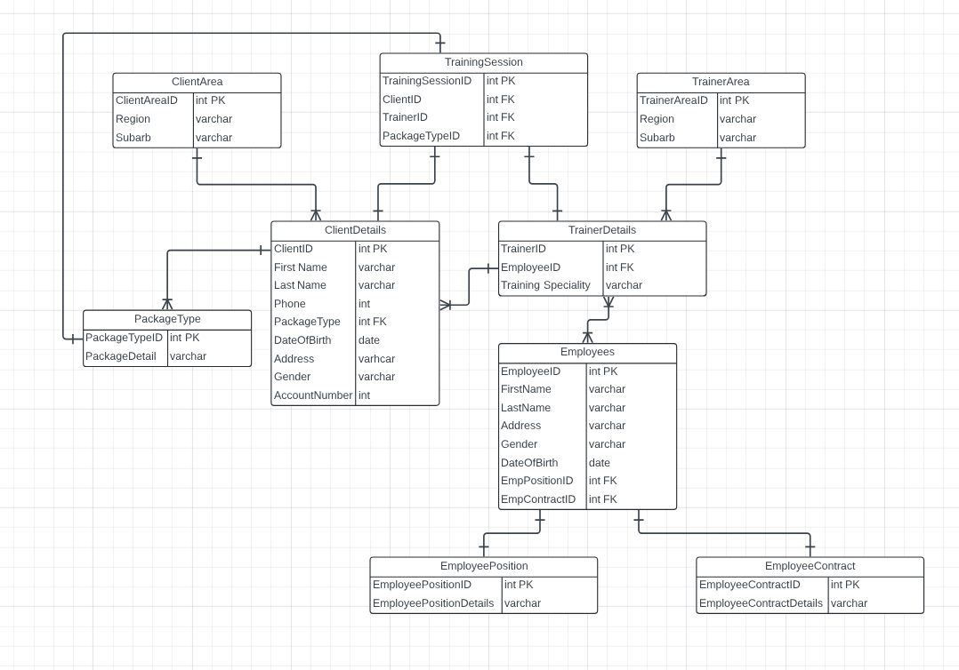

**Mock Ups**

